Minute Summary - “Cyber Run: Stop the Scam”
Our group is planning an educational game called Cyber Run: Stop the Scam. The game is inspired by endless runner games like Temple Run and teaches players about cyber safety, especially phishing awareness.
In this game, the character runs while fake emails, scam calls, and suspicious text messages appear on screen. Players must quickly decide whether each message is REAL or a SCAM. Correct answers earn points, while wrong answers reduce lives.
Today’s task is not to build the game yet. Our group only needs to:
- plan the idea
- discuss features
- assign team roles
- create sketches/storyboards
- prepare a simple project management plan
- organize a GitHub repository
The target audience is university students aged 18–25, because they regularly use online banking, email, and social media. The learning goal is to help players identify fake emails, scam calls, and scam messages in real-life situations.
Our group also prepares:
- Game Concept Canvas describing the game idea
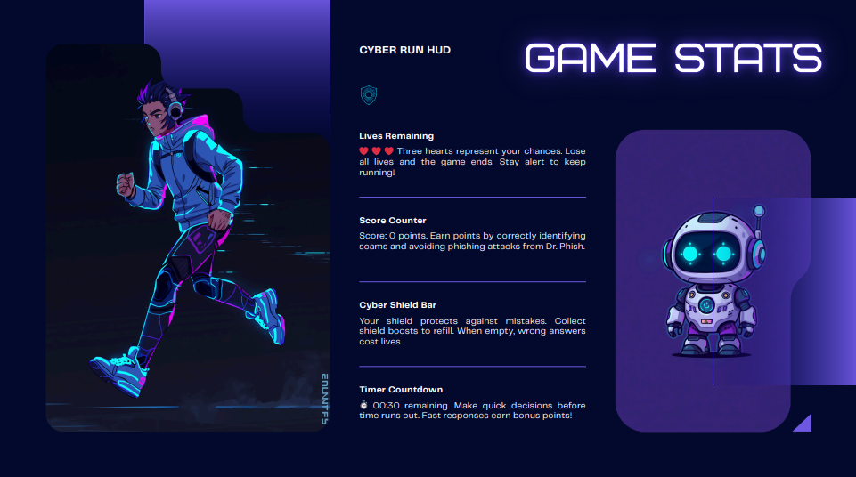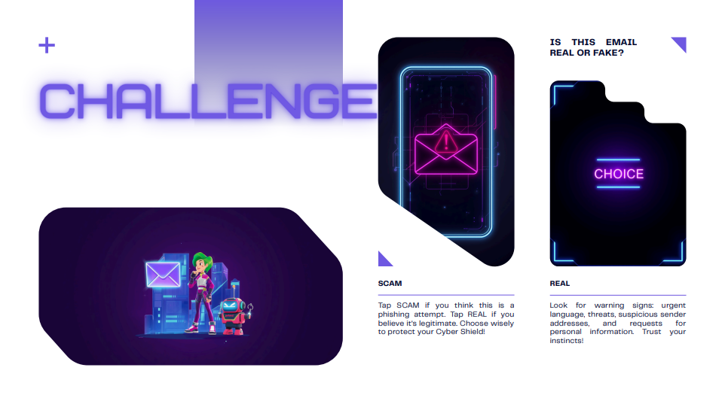

- Storyboard showing scenes of gameplay
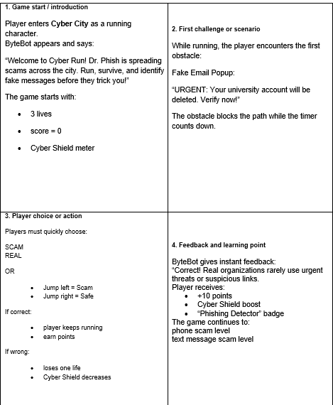
- Project Management Plan
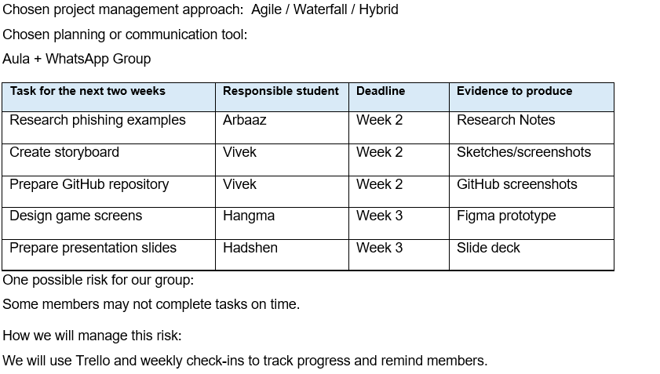

- GitHub Plan for teamwork and file sharing
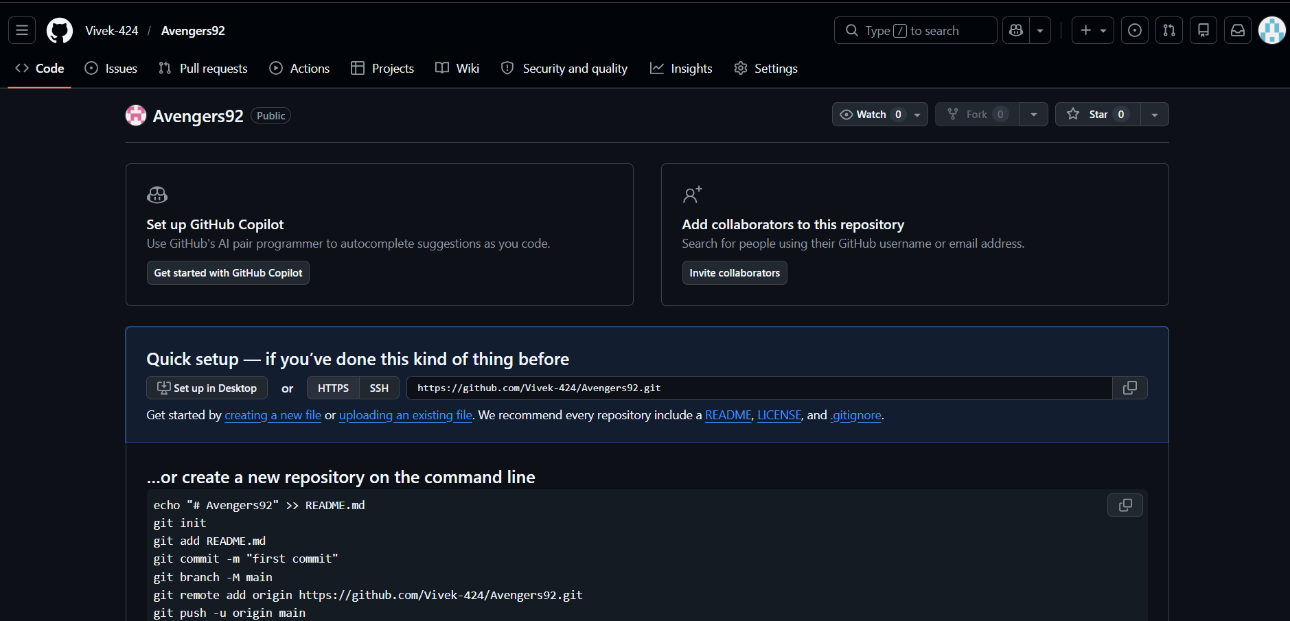
The teacher mainly wants evidence of teamwork, communication, creativity, planning & participation
Overall, Cyber Run: Stop the Scam is a simple, creative, and educational game idea that combines fun gameplay with cyber safety learning.

